Europe Cruise on Celebrity Equinox Journal
(10/16/2013-11/3/2013)

Helsinki, Finland ,

Arrived at the Helsinki Vantaa airport on 10/17/13 at 8:40 AM by Finnair. The Flight attendants were very friendly, with a genuine smile and sincere help. When he saw me going towards the restroom, he pushed the door open for me even though he already just passed it. The food and drink service is excellent. They served red and white wine, and two rounds. All other air companies which I had experience of offer non-alcohol drinks or with beer at the best. During non-service hours you can help yourself with juices such as apple, orange and tomato, and water, cold and hot, on the flight kitchen counter.

Finnair has a history of 90 years. Great airline. The one drawback we find is the attendant´s English announcements were not clear enough to be understood by non-Finnish speaking people. It has a strong Finnish accent.

We took the city bus 615 to the Hilton Strand Hotel with fair €4.50 each. The driver is black and extremely helpful. We told him our stop was Hilton Strand and show him the address when we got onboard the bus. When the bus was close to the hotel the driver waved towards us to come to the front. He pointed to the direction of the hotel and show us how to get there from the bus stop. He also told us the earliest bus to take is # 620 that start at 4:10am if we have get to the airport for the flight with the boarding time at 5:40am.

After an hour’s break at the hotel we toured the city on our own. We walked along the Unioninkatu/Unionsgatan street to the Market Square. We stopped to visit the Cathedral of Helsinki that is just one block away from the Square.. Before the Square we visited the Museum of Helsinki. The Square by the harbor is a market place for fresh produces. Crossing the street from the Square is the famous Mermaid statue and fountain. From there we walked to the shopping area, the business streets.

On Celebrity Equinox

10/18-10/20/2013: In Barcelona. From the airport we took the aerob minutes to the Hotel Husa Pedralbes, small and poorly maintained. Arrived there about 12:00 noon, they let us check in, room 104. We had to ask for hotwater pot, we bought our own socket adapter. Then we visited the L3 station area, walked along the D. BLVD.
10/19 we visited Sagrada Familia Church, Palau Guell ( the Guell Palace) and the Arch of Triumph (Arc de Triomf), the Fonda area where we had late lunch in a Wenzhou Chinese restaurant.
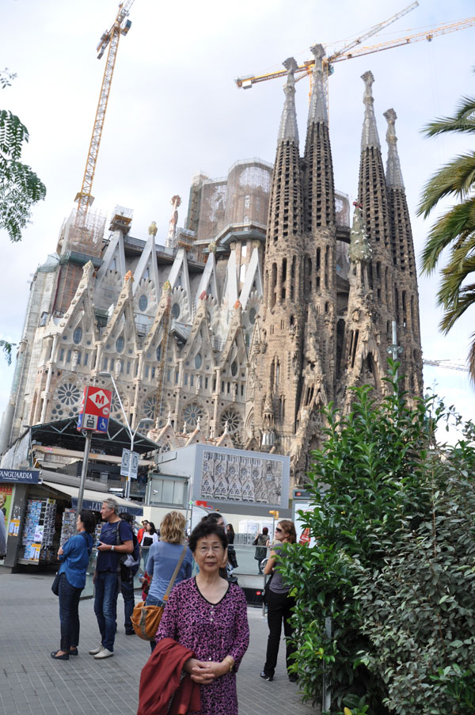
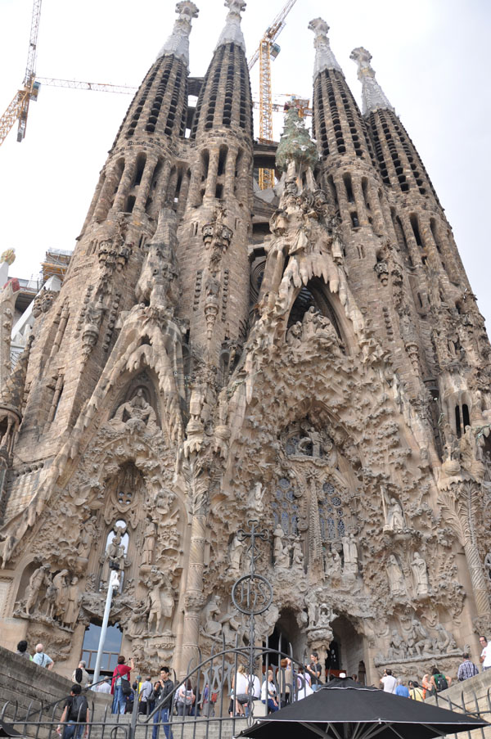
10/20 (Day 1) In the morning we stayed at the hotel, did some web pages, 高天明的《经营参考》 and some page on WhiteHouse and Interior Department pictures. We checked out at 11:30 am. Taking the L3 subway train to Drassanes and walked to the Columbus Statue square and took the blue bus to the Pear C where the Celebrity Equinox is docked.
10/21 (Day 2) The ship arrived at the city of Livornox. At about 7:30 ferryboats (Tenders) took us from the ship Celebrity Equinox to the city of Villefranche where we took the train to Monaco first. we visited Principaute de Monaco (摩纳哥大公国）on our own，the Prince Palace where the Prince actually lives now. Then we took the train back to Villefranche and further west to Nice Ville and strolled along the Walking street. Bought six bottles of beer and a shirt.
10/22 (Day 3) Visted Pisa and Florence. The ship docked in Livorno. This is the first tour in our package of Celebrity Signature. The but left Livorno at 8:30, the drive to Pisa took about one hour. The escort talked about the the two cities and the points to meet etc. After talking to the whole group she, Stefania, stepped down to the isle to answer individual questions. Pisa is a small city of 80,000 residents. All things to see are within the wall. The leaning tower is spetacular, all in marble stone.
From there we went to visit Florence, Firenze in Italian. Our first top is Santa Croce in Piazza Santa Croce (Santa Croce square). Santa Croce is the largest Franciscan church in Italy and holds the tombs of several important and famous Florentines including Michelangelo Buonarotti the artist, and Gallileo the physist. At the NE corner of the piazza stands the huge statue of Dante, the famous ancient Italian poet, who wrote Inferno. Then we went along narrow streets lined up with shops of real leather and we saw the famous leather school. Finally we arrived at the most famous Piazza della Signoria and Palazzo Vecehio. In the Piazza della Signoria we saw the statue of Michelangelo's David (copy). Thepiazza has been Florence's political center since the middle ages and Florence's town hall, the medieval Palazzo Vecehio, sits on the piazza. The Ponte Vecchio (old bridge), on the Arno River built in the 14th century (1345) is close by. It is the only ancient bridge left from Roman Empire times. The bridge is lined along both sides with gold and silver jewelry shops. All other ancient bridges were destroyed in the 2nd World War. Three police, two women and one man, were patroling along the narrow bridge. Baoyin wanted to take a picture with them and was refused. From there going north we went to Piazza del Duomo (the Cathedral Square), visited the cathedral of Santa Maria del Fiore. At the entrance we were asked to take off the hat. Visitors must wear clothes with their shoulders and knees covered. In the square we also saw the Bell Tower, the Campanile. The first story was designed by Giotto and it is commonly called Giotto's Campanile.
10/23 (Day 4) A taste of Rome. The ship docked at Civitavecchia, ITaly. Leaving the ship about 8:30 AM. Drove about 1 hour, arrived in Rome, Roma in Italian. A few minutes after we left the harbor we saw some remains of the ruined walls from the ancient Roman era. First visited the Colossium, Coloseo in Italian. From there we visited a church near by where there is Michelangelo's work of Moses with worried and indignant eyes. Michelangelo was a very diligent artist. He belonged to Vatica, was not allowed to study human anatomy. He went at night to find dead body to learn about human anatory. The muscils along Moses' arm were exact and vivid. Then we were taken to the Vatican City. Besides TianAnMen Square in China, we saw the largest visitor crowns in the world. From there we went to the Pantheon by going south along the via delle Conciliazione street, turning left through narrow streets we saw another crowded small squarfe with beautiful ancient high sculpture and a fountain of lower sculptures. Going further along the narrow streets we arrived at the Patheon Church.
10/24 (Day 5) Naples (Napoli) and Pompei, Italy. In the morning we visited the city of Naples on our own. We met a Tianjin man of about 60 years old. He came to Italy over 10 years ago. He does not have green card, has no status of residence. As in Roma, we saw many police with gus who are not as friendly as those in NYC. Some banks are guarded by gunmen.
Pompei is the best preserved remains of an ancient Roman city. The layout is still standing. We spent two hours visiting different parts of the ruins. All walls are the original, all roofs are later added. The lady guide told us that at that time women were treated almost as slaves, their status only above slaves. When watching games, they sat on the same highest level with slaves.
10/25 (Day 6) On the Sea. In the morning we first attended a talk on Europe tours cruise sales with complimentary wine and cocktails. The we listened to the Land Excursion direction's talk on the remaining three places to be visited: Kotor of Montenegro (黑山共和国）, Venice of Italy, and Dubrovnik of Croatia. For lunch I drank coffee and water only. In the afternoon I processed photos till 4:00 and then we played pingpong for half an hour. Worked at the photos for 40 mins; then we went to a formal dinner at the Silvouque Dining Room. A cup of white wine and a coke cost 10.50 Eur.
10/26 (Day 7) Kotor of Montenegro (黑山共和国，2006年独立）. Visited the small old city of Kotor, which is walled, three churches in it about 1hour and 30 mins. Then we walked along the seaside and a shopping center, bought three tins of coca cola. Returned to the ship about 11 am. We played pingpong for a while. In the afternoon we watched the ship sailing out the harbor from 3:30 to 5:00.
10/27 (Day 8) In the morning we saw the culinery show of exquisite food and taste of wine. Then played pingpong. I did not eat anything for lunch, worked on the photos. At 3:00 we went up to the 15th deck and watched the ship entering Venice, spectacular scenes of Venice. Played pingpong from 4:30 to 5:10. the we went down the ship and returned without going to Venice on our own because it was dark in the evening. We returned through customs, showing passports and going through all security procetures.
10/28 (Day 9) Visited Venice from early morning to 2:30 in the afternoon, the Doge's Palace which is fantastic. After visiting this museum, you don't have to see anything similar. It is the best, more impressive than the Vanselle in Paris, that we was in 2002. The glass factory display room is full of rare and beautiful products. The Palace Museum in Beijing is huge in area, it has more works of art, small wonders. But big, human-sized works of art are here in Venice! The sea is well preserved, very clean in the port area, but the city street canal water is smelly, just like the 臭水沟 in China. The Market Square (Puiazza San Marco) is like 外滩 in Shanghai.
10/29 (Day 10) Visited Dubrovnik of Croatia. The guide is very knowledgeable, she is a teacher of English & French. We visited a square and two churches. The guide talked about the war for independence a few years ago from the former Yugoslavia. The city was bombed badly, most of the buildings were shelled. She showed us a map posted on the city wall that marked with black triangles indicating the bombed points. She said Croatia does not have an regular army, only volunteers using poor weapons.
10/30 Wednesday- 10/31 Thursday: On ship
11/1 Friday: At Barcelona harbor disembarked Celebrity Equinox and lived in the Catalonia Atemas Hotel on the Aveida meridiana 151, Barcelona. Visited Catalonya Square in the afternoon.
11/2 Saturday: Left the hotel early morning to the airport; arrived in Helsinki, Finland about 3:30 in the afternoon. Checked in at the Crowne Plaza Hotel Helsinki. After dark had a walk on the street outside the hotel. Hade dinner at a Chinese restaurant.
11/3 Sunday: From 8am-10am walked to the city center, the railwaystation. Took Finnair bus to the airport at Vantaa, Helsinki.

